CHAUDHARY HAMDAN

1905387

Networks Lab 9

Q1. Implement different topologies in Cisco Packet Tracer.

Steps:

1. **We start by setting up the IP addresses of the PCs in the network followed by subnet mask, which automatically gets set.**
2. **Then we use automatic connection cables to do connections in between the devices in the network.**
3. **We also used Switches or Hubs where ever needed to do appropriate way of connection.**
4. Point to Point

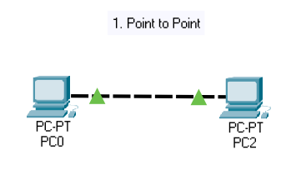

1. Bus Topology

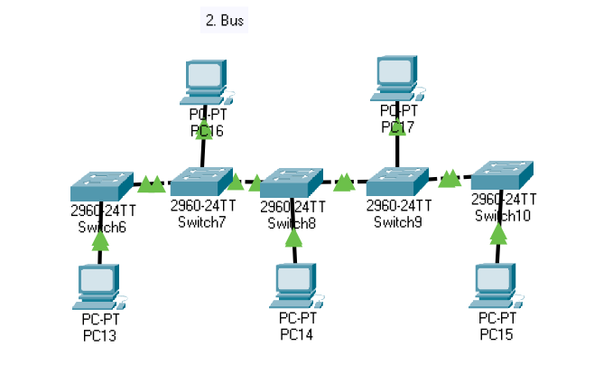

1. Ring Topology

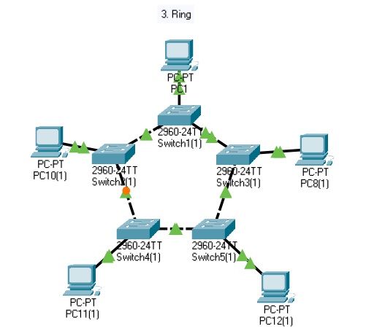

1. Star Topology

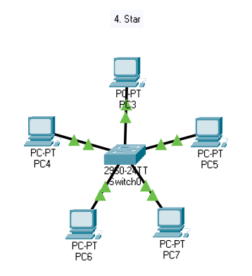

1. Mesh Topology

